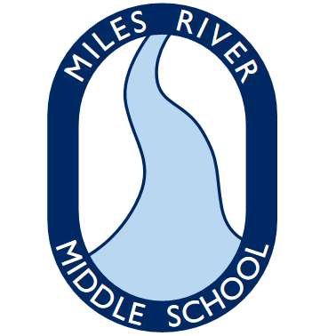
Grade 8 Supplies
Miles River Middle School
Hamilton, MA

Welcome to Grade 8

To get ready for the 2019-2020 school year, please gather the following supplies:

  - 1.5 inch 3-ring binder - 5 (English, Civics, Science, Math, World Language) - different colors
  - Lined paper - 2 pkg 250 count, 3 hole punched
  - Ruled index cards - 2 pkg 100 count, 3x5
  - 2-pocket folder for homework - 1 plastic and VERY sturdy – NO HOMEWORK BINDER
  - 2-pocket folder - 2 (not plastic) for English
  - Composition notebook – 2 (1 for science and 1 for English)
  - Highlighters - 1 multi-pack
  - Colored pens for correcting
  - #2 Pencils - 2 packs
  - Box of tissues - 1-2
  - Package of page protectors
  - Dividers - 1 pack
  - Scientific Calculator - 1
  - Sturdy pencil case - 1

*Note: Additional items may be requested for specific classes during the first weeks of school

